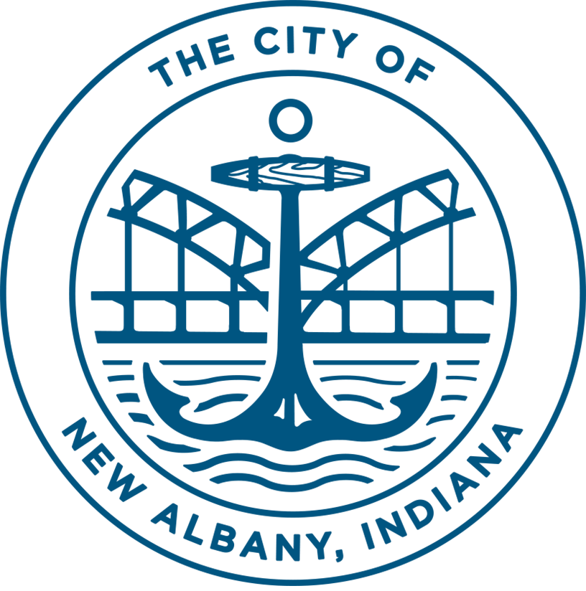
PUBLIC NOTICE
Proposed Amendment to the City of New Albany’s
2020-2024 CDBG Consolidated Plan & FY20 One-Year Action Plan
Under the Coronavirus Aid, Relief, & Economic Security Act (CARES Act), the US Department of Housing & Urban Development (HUD) has awarded the City of New Albany $589,501, additional CDBG funding. An amendment for a portion of that funding was submitted to HUD on October 15, 2020. The City needs to amend its 2020-2024 Consolidated Plan and the 2020 One-Year Action Plan for the remaining $428,001, to respond to the changing needs in the community as a result of the COVID-19 Pandemic.
The New Albany Redevelopment Commission proposes the following activities that respond to the COVID-19 Pandemic:
Public Facility-Neighborhood Health Clinic: Rehabilitation of a vacant and under-utilized commercial property for a neighborhood health clinic that will be operated by a non-profit for patients who have no insurance or who are underinsured to seek medical care to address public health and receive non-emergency diagnosis and treatment for infectious diseases such as COVID-19, (including testing and vaccinations once approved by local health officials) among other health issues. The improvements will include interior rooms, cabinets, flooring, lighting, plumbing, and mechanical system as needed. $348,000
Administration - Program administration and oversight of the CDBG-CV Program. $80,001
The New Albany Redevelopment Commission (Commission) held a Public Hearing via Zoom on January 26, 2021. The Commission will approve the DRAFT amendment on February 23, 2021, and publish this summary in the News and Tribune on February 26, 2021. The entire FY20 Plan, including the amendment will be posted on the City of New Albany’s website at www.cityofnewalbany.com, beginning Friday, February 26, 2021, for a comment period.
HUD has issued guidance that that reduces the public comment period to not less than five (5) days and reasonable notice and opportunity to comment. A comment period will begin on February 26, 2021, and conclude on March 5, 2021. The public may comment in writing by emailing Josh Staten, Redevelopment Director at jstaten@cityofnewalbany.com or mail to Redevelopment Director at 311 Hauss Square, Room 325, City-County Building, New Albany, IN 47150. Following the comment period for the amendment the Commission will adopt the amendment on March 9, 2021, and the City of New Albany will submit the amendment to HUD on or after March 10, 2021.

