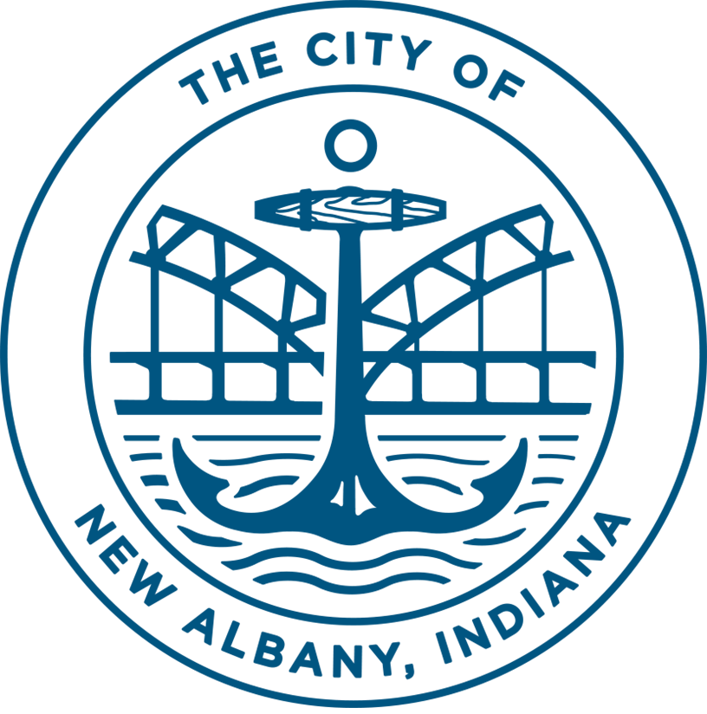
PUBLIC NOTICE
Proposed Amendment to the City of New Albany’s
2020-2024 CDBG Consolidated Plan & FY20 One-Year Action Plan
Under the Coronavirus Aid, Relief, & Economic Security Act (CARES Act), the US Department of Housing & Urban Development (HUD) has awarded the City of New Albany $589,501, additional CDBG funding. To prepare for this funding the City needs to amend its 2020-2024 Consolidated Plan and the 2020 One-Year Action Plan to respond to the changing needs in the community as a result of the COVID-19 Pandemic.
HUD has issued guidance that that reduces the public comment period to not less than five (5) days and reasonable notice and opportunity to comment. The New Albany Redevelopment Commission will hold a Public Hearing via Zoom on October 13, 2020. The ZOOM information will be posted at www.newalbanycityhall.com.
A comment period will begin on September 25, 2020, and conclude on October 13, 2020, after the Public Hearing at which time the New Albany Redevelopment Commission will consider the amendment for adoption. The public may also comment in writing by emailing Josh Staten, Redevelopment Director at jstaten@cityofnewalbany.com or mail to Redevelopment Director at 311 Hauss Square, Room 325, City-County Building, New Albany, IN 47150. Following the adoption of the amendment, the City of New Albany will submit the amendment to HUD on or about October 14, 2020.
The proposed activities are as follows:
Emergency Subsistence Payments – This activity will provide payments including rental or mortgage assistance, utilities, deposits, etc., for a maximum of up to 6 consecutive months to those household affected by financial loss due to the COVID-19 Pandemic and prevent foreclosures and evictions. $100,000
Food Insecurity - This activity will respond to and provide food to those affected by the COVID-19 Pandemic through Blessings in a Backpack. $35,000
Economic Gardening Program – A Purdue Program meant to support and provide technical assistance for retention and recovery for businesses related to the affects of the COVID-19 Pandemic. $17,500
Administration - Program administration and oversight of the CDBG-CV Program by Redevelopment staff. $9,000

